March 27, 2008

Edward Adelson
Associate Executive Dean
Colleges of the Arts and Sciences
114 University Hall
230 N Oval Mall
CAMPUS

Dear Ed,

The College of the Arts Curriculum Committee has reviewed and voted unanimously to support the Department of Art’s proposal to revise the entrance requirements for the undergraduate Bachelor of Fine Arts (a tagged degree approved by OAA in May of 1990) and Bachelor of Arts major program. We discussed the proposal with Professor Rebecca Harvey, Chair of Undergraduate Studies in the Department of Art, during our ARTS CC deliberations on Monday, January 8, 2008 and on Monday, March 3, 2008, and we were pleased to unanimously support the Department of Art’s changes to the B.A./B.F.A entrance requirements.

The proposal was vetted and supported by the full faculty in the department, designed in close consultation with the Arts Advising Staff, and the Department of Art Education, and went through two revisions with the Arts CC. The Department of Art Undergraduate Studies Chair and the Department of Art Education Undergraduate Studies Chair met several times to streamline the two proposals so that their students may flow seamlessly from the BFA in Art into the senior year of the BAE in Art Education. The revisions are reflective of the field, the interdisciplinary strengths of the department, and the observations of the accrediting body of the National Association of Schools of Art and Design (NASAD). The Department has created new “checksheets” of each of its BFA emphasis areas (Glass, Printmaking, Sculpture, Art and Technology, Photography, Ceramics, Drawing and Painting) and for its BA degree so that Advisors in Arts Advising, students, and faculty will have a clear template to follow.

The BFA tagged degree is currently 196 credit hours, with 76 in the General Education Curriculum and 120 in the major program. These will remain unchanged. The primary changes are described below:

- GEC reflects the revised GEC with the current/new categories.

- The entrance requirements are changed from a tiered process of first coming in as pre-Art, then portfolio-reviewing into the BA, then another portfolio review into BFA, to entering as a BFA art student who, after 5 Foundations courses, will have his or her work reviewed by the Foundations Director and the Academic Standards Committee. This focused approach is reflective of the values of the department, puts students on track for the tagged degree in either Art or Art Ed, and adheres to NASAD standards. With this method, the creative process is able to factor into a student’s potential, rather than just the end product. It will also help the faculty identify students much earlier in the process who may be in trouble.

- New Advising Process will reach a greater number of students and ensure that they are receiving the appropriate information. The department and Arts Advising will work in tandem to advise students.

- This change to enter as BFA in Art will consequently strengthen the BA as the process to become a BA helps the students define the clear objectives and ensures focused studies to create a strong BA degree plan and not just a generalist degree. Entering as a BFA also will align students at a much earlier stage to be successful in the BAE.

- The changes will take place in Autumn 2008 for entering freshman and transfer students. The department is requesting two codes 066 for BA in Art and 065 for BFA in Art. Art Education will retain 067 for its majors and 849 for Pre-Art Ed.

- In Autumn 2008 any current student will have the opportunity to declare BA or BFA in Art.

We thank you in advance for moving this proposal through the next appropriate steps, and look forward to its ultimate approval and implementation for fall of 2008. If you have questions about the proposal please feel free to contact me at 292-5171 or through email, mockabee.1415.

Thank you,
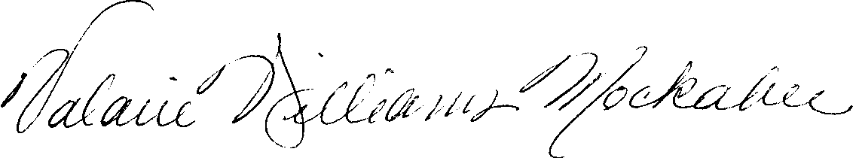
Valarie Williams Mockabee
Associate Dean, College of the Arts

cc: Rebecca Harvey, Undergraduate Chair, Department of Art
ARTS CC

